South Woodham Preschool

Summer Newsletter : October 2026
LOOKING BACK…..
At Stepping Stones the children have enjoyed lots of fun activities this half term. Their creative work has included marble painting, creating a flower, rainbow and an Autumn tree. During free creative work they have practiced their scissor skills Autumnal collaging, leaf painting, stencil drawing and playdough. Their investigative work has included learning about magnets, playing Kim’s game, experimenting with Wizards Brew. Thank you to everyone who has sent in donations to our local food bank for Harvest Festival. These will be very much appreciated.
WHAT’S HAPPENING NEXT HALF TERM:
Breakfast Club
We are pleased to be starting our Breakfast Club after half term on a Tuesday morning. As and when more interest is shown for other days we will increase these and introduce After School Club. Breakfast Club will run from 7.45am at a cost of £7.50.
October Half Term Scavenger Hunt
Your child has been given a scavenger hunt during the last week of term for them to complete over the half term holiday. We would love to see as many back after the holiday for the children to talk to their friends about and display in the main room.
Children in Need Week – 9th-13th November
We encourage the children to wear anything red, yellow or spotty and make a donation to Children in Need.
Christmas Bazaar & Family Photographs – Saturday 28th November
We will be holding a Christmas Bazaar here at pre-school from 9am-1pm and would love for you all to come along. The photographer will be here too to take individual or family photos. If you would like to book a slot details will be emailed out after half term.
Cake Donations for our Christmas Bazaar cake stall
We would be delighted to receive any cake donations from our lovely parents/carers for our cake stall during the week of 23rd November. Many thanks in advance for your support.

Raffle Tickets
During November we will be sending out raffle tickets for you to sell to your family and friends for our Christmas raffle. This will be drawn on Monday 7th December. We also welcome donations of raffle prizes. We thank you for your continued support.
Christmas Jumpers 14th December to the end of Term. We encourage the children to wear their favourite Christmas jumper, t-shirt or dress to pre-school to round off the end of term.
Lunch Boxes

Government recommendations on healthy eating for Early Years are that sweet treats should be limited and not consumed in excess. Can we please ask that only one sweet treat (no sweets or chocolate bars) is given in your child’s lunchbox i.e. biscuit/kitkat/cake etc and that all food items are cut up appropriately to avoid them becoming a choking risk. Here is a link to the recommendations:

https://www.foundationyears.org.uk/files/2021/09/Early-Years-Choking-Hazards-Table_FINAL_21-Sept-2021.pdf

Please NO nuts/nut products or sesame seeds should be brought into pre-school. Could parents please write your child’s name INSIDE and OUTSIDE of their lunch box/bag as we have a few that are the same and lastly please ensure all children bring in with them a drink of water in a named sports style bottle. Many thanks for your continued support.

Child Absences:
Could we please ask that if your child is going to be absent from preschool that you either email or phone into the office on the first day of absence and the reason for the absence. This is in line with our safeguarding policy. If we do not hear anything we will be in contact to confirm the reason for not attending. Thank you for your understanding.

Illness
Can we also remind parents/carers that if you need to give your child Calpol before coming into preschool as your child is suffering from a temperature please keep them at home. We understand your need for childcare however, with so many different infections around this helps with the spread and also from any staff shortages due to illness. Also, if your child has been given antibiotics and/or had diarrhea/sickness our policy is for them to not attend preschool for 48 hours in case of a reaction and also to avoid the spread to others. Thank you for your understanding and co-operation.
Festivals

If there are any special festivals that your family celebrate throughout the year we would love to hear about them. Please let a member of staff know and we will include this within our learning.

Drinks:
The EYFS framework (statutory requirements) states that Early Years providers must promote good oral health of children who attend their setting. Ofsted will also assess settings on how they promote good oral health.
We therefore ask that when providing your child with their “named” sports bottle to access throughout the session they only contain water. We will refill these throughout the session with fresh water.
As usual all the children (dependent on allergies) will be offered milk or water at snack time on session.

PANTOSAURUS.
Talking PANTS teaches children important messages, like their body belongs to them and they should tell an adult if they're upset or worried. Please take the time to watch this short animation and share with your child.


https://youtu.be/-lL07JOGU5o

SAFEGUARDING

For online safety advice please visit www.nspcc.org.uk/keeping-children-safe/online-safety
To download a guide for under 5’s please visit www.internetmatters.org/advice/0-5

Please be aware that we will always try our best to keep pre-school open in severe weather conditions but if we are forced to close a message would be placed on our website and Facebook page.

PLEASE, PLEASE, PLEASE ensure you send your child to pre-school in appropriate clothing/footwear for the season. All items of clothing including jackets and hats should be named. Appropriate footwear worn for safe play in the garden and inside (no CROCS or open toed sandals). If your child wears wellie boots on their journey to preschool please ensure they have appropriate shoes to change into.
If you are potty training your child please supply a few changes of clothes in their bag for ‘accidents’, including shoes. We do have spare clothes, but are limited on choice/sizes.

Late Pick Up!
Can we please ask that you are prompt to collect your children at the end of session. This causes distress to the children who are waiting and also can affect the numbers of children we have on the premises especially in the afternoon when we are already full and children aren’t collected on time. We thank you for your co-operation and understanding.

 Please join us at our Facebook Closed Group.

Fundraising since last newsletter:-

Gift Aid from Sponsored Toddle - £97.35

APPEAL FOR NEW COMMITTEE MEMBERS & FUNDRAISERS
As you are all aware we rely heavily on our Committee through the support of our parents. We have had quite a few members leave this year and really need more parents to join. If you feel this is something you would like to be involved with please speak contact any of the current Committee members or speak to a member of staff. Please be aware that a role on the Committee can be as little as giving up a few hours for any events that are being held or a more involved role as one of our Officers.

PLEASE NOTE THAT WHETHER YOU CHOOSE TO PAY YOUR FEES MONTHLY, HALF TERMLY OR TERMLY PAYMENTS SHOULD BE MADE AT THE BEGINNING OF A MONTH OR AT THE BEGINNING OF THE TERM.

NON-PAYMENT OF FEES:
IF FEES ARE NOT PAID PROMPTLY THE COMMITTEE WILL NOW BE PUTTING A FREEZE ON “PAID FOR” SESSIONS AND ANY “EXTRAS” THAT ARE NOT COVERED BY FUNDING. PLEASE BE AWARE AS A CHARITY WE RELY ON PROMPT PAYMENT OF FEES TO ALLOW US TO MEET ALL OF OUR FINANCIAL COMMITMENTS.

OUR FAMILY BOARD: We continue to use our ”Family Board” and would ask that any children who haven’t already done so to bring in a photograph of their family and/or extended family. This board is used to celebrate diverse family structures, cultures and religions and to encourage the children to talk about their own relations and identify and embrace similarities and differences.

NUMBER FOR REPORTING ABSENCES: 01245 425746
Could we please ask that any absences be made either by email to management@southwoodhampreschool.co.uk or by leaving a voicemail message on the landline.

SNACK DURING SESSION NEXT HALF TERM:-

Week 1 - Toast & Cucumber
Week 2 - Cream Crackers & Pears
Week 3 - Breadsticks & Apples
Week 4 - Crispbread & Cucumber
Week 5 - Cereal & Satsumas
Week 6 - Use up from previous weeks
Week 7 - Party Food
IDEAS FOR SNACK
We would appreciate suggestions of any favourite healthy snacks your child has that we could possibly add to our selection of snack choices we offer the children.

Healthy Packed Lunches for Early Years - A practical Guide for Parents and Carers can be found at www.childrensfoodtrust.org.uk/childrens-food-trust/early-years
Ten Steps for Healthy Toddlers : https://infantandtoddlerforum.org/media/upload/pdf-downloads/HR_toddler_booklet_green.pdf
SCOOTERS/BIKES
Unfortunately, we are unable to store any scooters/bikes during the day while your children are at pre-school.

YOUR CHILD’S DEVELOPMENT

If you have any concerns about your child’s speech please speak with your key person at any time. Also, you can access an on-line basic assessment at www.talkingpoint.org.uk which gives guidance to parents about the ages/stages of a child’s speech development.

UNIFORM

Please fill out an order form, which can be found in the foyer or email into the office with your order.

Price List:
T-shirt | £7.50
Polo Shirt | £8.50
Sweatshirt | £12.00
Fleece | £14.00
Book Bag | £7.00
Cap | £7.00

SECOND HAND UNIFORM. We have a selection of second hand uniform that we sell for £1 each for t-shirts and polo shirts, £2 each for sweatshirts and £2.50 for fleeces.
FOR YOUR INFORMATION A LIST OF THE 14 FOOD ALLERGENS ARE LISTED BELOW:-

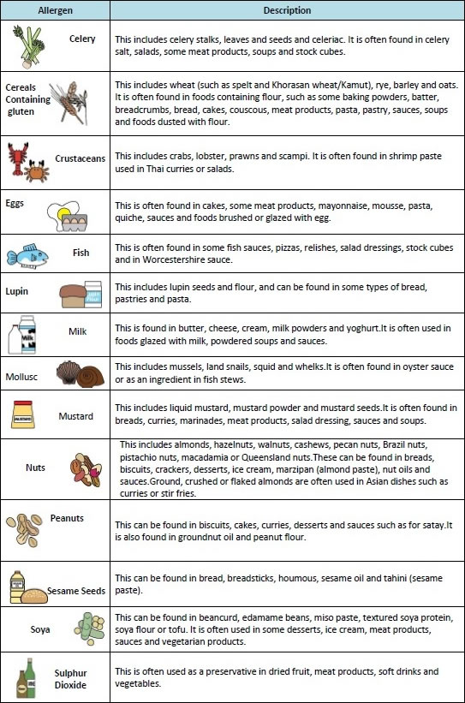

TERM DATES:
Fri 23rd Oct | Last Day of Half Term
Mon 26th – Fri 30th Oct | Half Term Holidays
Mon 2nd Nov | Start of New Half Term
Thurs 17th Dec | Last Day of Term
Fri 18th Dec | Stepping Stones Sing-a-long *
Mon 21st – Thurs 31st Dec | Christmas Holidays
Fri 1st January 2027 | Bank Holiday
Mon 4th Jan | Start of Spring Term
Fri 12th Feb | Last Day of Half Term
Mon 15th – Fri 19th Feb | Half Term Holidays
Mon 22nd Feb | Start of New Half Term
Thurs 25th March | Last Day of Term
Fri 26th & Mon 29th March | Bank Holidays
Tues 30th March – Fri 9th April | Easter Holidays
Mon 12th April | Start of Summer Term
Mon 3rd May | Bank Holiday
Fri 28th May | Last Day of Half Term
Mon 31st May | Bank Holiday
Tues 1st – Fri 4th June | Half Term Holidays
Mon 7th June | Closed for Staff Training
Tues 8th June | Start of New Half Term
Thurs 15th July | Last Day of Term
Fri 16th July | Stepping Stones Graduations *
*Details will be sent out nearer the time.

We would like to wish all our children, parents and carers a lovely half term break.
We look forward to seeing you all back on Monday 2nd November 2026.


