South Woodham Preschool

Autumn Newsletter : December 2025
LOOKING BACK…..
They have enjoyed our role play area set up as a construction site, a restaurant, a doctors surgery, a vets and Santa’s Workshop.
At Stepping Stones the children have enjoyed lots of fun activities this half term. Their creative work has included threading, making firework pictures, invitations to the Stepping Stones Nativity, using shapes for a purpose, making a Christmas storybook, making snowflakes, Christmas jumpers, wreaths and candy canes. Their investigative work has included making poppies, exploring textures, baking Christmas cookies and dress rehearsals and lots of singing practice for our Nativity on 18th December.
We wish a warm welcome to our new starters next term: Amelie, Harrison, Isla, Molly, Nancy, Olive, Oscar and Tristan.
WHAT’S HAPPENING NEXT HALF TERM:
Stepping Stones: We will be starting our “Letter of the Week” from the start of next term (w/c 5th January). Each week the children are encouraged to bring in something (i.e. small toy or object) beginning with the letter we are focusing on. This term we start with “A” then second week letter “B” and so on. This is for Stepping Stones sessions only.

Friday 13th February – Closed for Staff Training

Lunch Boxes
Government recommendations on healthy eating for Early Years are that sweet treats should be limited and not consumed in excess. Can we please ask that only one sweet treat is given in your child’s lunchbox i.e. biscuit/kitkat/cake etc and that all food items are cut up appropriately to avoid them becoming a choking risk. Here is a link to the recommendations:
https://www.foundationyears.org.uk/files/2021/09/Early-Years-Choking-Hazards-Table_FINAL_21-Sept-2021.pdf
Please NO nuts/nut products or sesame seeds should be brought into pre-school. Could parents please write your child’s name INSIDE and OUTSIDE of their lunch box/bag as we have a few that are the same and lastly please ensure all children bring in with them a drink of water in a named sports style bottle. Many thanks for your continued support.

Child Absences:
Could we please ask that if your child is going to be absent from preschool that you either email or phone into the office on the first day of absence and the reason for the absence. This is in line with our safeguarding policy. If we do not hear anything we will be in contact to confirm the reason for not attending. Thank you for your understanding.

Illness
Can we also remind parents/carers that if you need to give your child Calpol before coming into preschool as your child is suffering from a temperature please keep them at home. We understand your need for childcare however, with so many different infections around this helps with the spread and also from any staff shortages due to illness. Also, if your child has been given antibiotics and/or had diarrhea/sickness our policy is for them to not attend preschool for 48 hours in case of a reaction and also to avoid the spread to others. Thank you for your understanding and co-operation.
Festivals

If there are any special festivals that your family celebrate throughout the year we would love to hear about them. Please let a member of staff know and we will include this within our learning.

Drinks:
The EYFS framework (statutory requirements) states that Early Years providers must promote good oral health of children who attend their setting. Ofsted will also assess settings on how they promote good oral health.
We therefore ask that when providing your child with their “named” sports bottle to access throughout the session they only contain water. We will refill these throughout the session with fresh water.
As usual all the children (dependent on allergies) will be offered milk or water at snack time on session.

PANTOSAURUS.
Talking PANTS teaches children important messages, like their body belongs to them and they should tell an adult if they're upset or worried. Please take the time to watch this short animation and share with your child.


https://youtu.be/-lL07JOGU5o

SAFEGUARDING

For online safety advice please visit www.nspcc.org.uk/keeping-children-safe/online-safety
To download a guide for under 5’s please visit www.internetmatters.org/advice/0-5

Please be aware that we will always try our best to keep pre-school open in severe weather conditions but if we are forced to close a message would be placed on our website and Facebook page.

PLEASE, PLEASE, PLEASE ensure you send your child to pre-school in appropriate clothing/footwear for the season. All items of clothing including jackets and hats should be named. Appropriate footwear worn for safe play in the garden and inside. If your child wears wellie boots on their journey to preschool please ensure they have appropriate shoes to change into.
If you are potty training your child please supply a few changes of clothes in their bag for ‘accidents’, including shoes. We do have spare clothes, but are limited on choice/sizes.

Late Pick Up!
Can we please ask that you are prompt to collect your children at the end of session. This causes distress to the children who are waiting and also can affect the numbers of children we have on the premises especially in the afternoon when we are already full and children aren’t collected on time. We thank you for your co-operation and understanding.

 Please join us at our Facebook Closed Group.

Fundraising since last newsletter:-

Raffle Tickets - £91?
October Half Term Scavenger Hunt - £18.00
Children in Need - £15.00
Christmas Mini-Bazaar and Cake Sale - £229.94

APPEAL FOR NEW COMMITTEE MEMBERS & FUNDRAISERS
As you are all aware we rely heavily on our Committee through the support of our parents. We have had quite a few members leave this year and really need more parents to join. If you feel this is something you would like to be involved with please speak contact any of the current Committee members or speak to a member of staff. Please be aware that a role on the Committee can be as little as giving up a few hours for any events that are being held or a more involved role as one of our Officers.

PLEASE NOTE THAT WHETHER YOU CHOOSE TO PAY YOUR FEES MONTHLY, HALF TERMLY OR TERMLY PAYMENTS SHOULD BE MADE AT THE BEGINNING OF A MONTH OR AT THE BEGINNING OF THE TERM.

NON-PAYMENT OF FEES:
IF FEES ARE NOT PAID PROMPTLY THE COMMITTEE WILL NOW BE PUTTING A FREEZE ON “PAID FOR” SESSIONS AND ANY “EXTRAS” THAT ARE NOT COVERED BY FUNDING. PLEASE BE AWARE AS A CHARITY WE RELY ON PROMPT PAYMENT OF FEES TO ALLOW US TO MEET ALL OF OUR FINANCIAL COMMITMENTS.

OUR FAMILY BOARD: We continue to use our ”Family Board” and would ask that any children who haven’t already done so to bring in a photograph of their family and/or extended family. This board is used to celebrate diverse family structures, cultures and religions and to encourage the children to talk about their own relations and identify and embrace similarities and differences.

NUMBER FOR REPORTING ABSENCES: 01245 425746
Could we please ask that any absences be made either by email to management@southwoodhampreschool.co.uk or by leaving a voicemail message on the landline.

SNACK DURING SESSION NEXT HALF TERM:-

Week 1 - Cereal & Cucumber
Week 2 - Crackers & Apples
Week 3 - Breadsticks & Carrots
Week 4 - Crispbread & Pears/Satsumas
Week 5 - Toast & Cucumber
Week 6 - Use up from previous weeks

FOR YOUR INFORMATION A LIST OF THE 14 FOOD ALLERGENS ARE LISTED BELOW:-

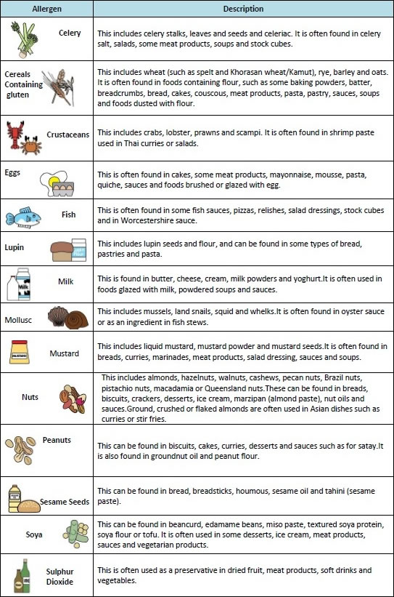

IDEAS FOR SNACK
We would appreciate suggestions of any favourite healthy snacks your child has that we could possibly add to our selection of snack choices we offer the children.

Healthy Packed Lunches for Early Years - A practical Guide for Parents and Carers can be found at www.childrensfoodtrust.org.uk/childrens-food-trust/early-years
Ten Steps for Healthy Toddlers : https://infantandtoddlerforum.org/media/upload/pdf-downloads/HR_toddler_booklet_green.pdf

SCOOTERS/BIKES
Unfortunately, we are unable to store any scooters/bikes during the day while your children are at pre-school.

YOUR CHILD’S DEVELOPMENT

If you have any concerns about your child’s speech please speak with your key person at any time. Also, you can access an on-line basic assessment at www.talkingpoint.org.uk which gives guidance to parents about the ages/stages of a child’s speech development.

UNIFORM

Please fill out an order form, which can be found in the foyer or email into the office with your order.

Price List:
T-shirt | £7.50
Polo Shirt | £8.50
Sweatshirt | £12.00
Fleece | £14.00
Book Bag | £7.00
Cap | £7.00

SECOND HAND UNIFORM. We have a selection of second hand uniform that we sell for £1 each for t-shirts and polo shirts, £2 each for sweatshirts and £2.50 for fleeces.

TERM DATES:
Weds 17th Dec | Last Day of Autumn Term
Thurs 18th Dec | Stepping Stones Nativities *
Fri 19th Dec – Fri 2nd Jan 2026 | Christmas Holidays
Mon 5th Jan | Start of Spring Term
Thurs 12th Feb | Last Day of Half Term
Fri 13th Feb | Closed for Staff Training
Mon 16th – Fri 20th Feb | Half Term Holidays
Mon 23rd Feb | Start of New Half Term
Mon 2nd – Fri 6th March | Sponsored Bounce Week *
Fri 27th March | Last Day of Spring Term
Mon 30th March – Fri 10th April | Easter Holidays
Mon 13th April | Start of Summer Term
Fri 22nd May | Last Day of Half Term
Mon 25th – Fri 29th May | Half Term Holidays
Mon 1st June | Closed for Staff Training
Tues 2nd June | Start of New Half Term
Thurs 16th July | Last Day of Summer Term
Fri 17th July | Stepping Stones Graduations *
*Details will be sent out nearer the time.

We would like to wish all our children, parents and carers
a Merry Christmas & a Happy New Year
We look forward to seeing you all back on Monday 5th January 2026



